DMV CDL and Bus Permit Requirements

NEW CDL DRIVERS
Fill out yellow application form.
Present proof of US Citizenship or lawful status ONE TIME.
Present current driver license.
Present two forms of proof of residential address
if not proven in the past.
Check box A,B,C or D for CDL medical certification.
(Most drivers choose A or B to avoid intrastate restriciton)
Pass written tests for Commercial Learners Permit (CLP).
(General Knowledge, Air Brakes, Passenger, School Bus)
Study materials are in CDL Drivers Manual.
Obtain Class B CLP with P/S endorsements and P restriction.
Practice driving bus with school. Will include completing the Pre-Drive Evaluation and submitting it to the Nebraska Safety Center.
Schedule appointment for skills test for CDL as soon as day after
CLP is issued.
CLP must be held at least 14 days before skills tests can occur.
Study Vehicle Inspection practice videos on DMV website.
Study sections 10-13 of CDL Drivers Manual.
Pass Vehicle Inspection, Basic Control Skills and Road Test for CDL.
Get Class B or C CDL with P/S endorsements issued.
CDL expires on birthday in five years.

CDL RENEWAL DRIVERS (every five years)
May apply for renewal up to 90 days in advance of expiration date.
Fill out yellow application form.
Present proof of US Citizenship or lawful status ONE TIME (if not previously presented.)
Present current CDL.
Present two forms of proof of residential address
if not proven in the past.
Check box A,B,C or D for CDL medical certification.
(Most drivers choose A or B to avoid intrastate restriciton)
Obtain renewal CDL.
CDL expires on birthday in five years.

CDL application data forms: http://www.dmv.nebraska.gov/forms
Acceptable documents for proof of citizenship/identification:
http://www.dmv.nebraska.gov/examining/pdf/verificationdocs.pdf

To schedule CDL skills tests with the DMV, call the appt line:
(402-471-7983)
Drivers are HIGHLY ENCOURAGED to view a practice Vehicle Inspection video prior to taking the skills test:
http://www.dmv.nebraska.gov/examining/School_Bus_pretrip_video.html

NEW BUS PERMIT APPLICANTS
Complete Dept of Ed Level I training. Must be on DMV computer
system to test for bus permit.
Fill out yellow application form. (can be same form as used for CDL if
applying at same time.)
Present current driver’s license.
Present two forms of proof of residential address
if not proven in the past.
Present long form DOT Physical (not the small card.)
Pass DMV Vision screening test.
Pass written test for bus permit. (Class D/E Bus Permit take
S endorsement written test, so if you are taking that for
the CDL at same time, it covers both.)
Class A Bus Permit applicants – pass Class O written test.
Class B/C Bus Permit applicants – pass Neb School Bus Test.
(Study Pupil Transportation Guide)
For a Class D/E Bus Permit, once CDL is either obtained or
all required skills testing is passed, pass short 15-20 min
road test in school bus. Focus is on railroad
crossing and Student Pickup (Class D only).
For Class A Bus Permit, pass regular Class O road test.
For Class B/C Bus Permit, pass short 15-20 min
Road test in school bus. Focus is on railroad crossing
and Student Pickup (Class B only).
Get Bus Permit issued. Bus Permit expires on birthday each year.

RENEWAL BUS PERMIT APPLICANTS (every year)
Complete Dept of Ed Level II training once Level I expires. Must be
on DMV computer system to test for bus permit.
May apply for renewal up to 90 days in advance of expiration date.
Fill out yellow application form. (can be same form as used for CDL if
applying at same time.)
Present current driver’s license. Present current bus permit.
Present two forms of proof of residential address
if not proven in the past.
Present long form DOT Physical (not the small card.)
Pass DMV Vision screening test.
If a year CDL/Driver License DOESN’T expire, get Bus Permit issued.
(WRITTEN AND DRIVE TEST ONLY REQUIRED YEAR CDL/LICENSE EXPIRES):
Pass written test for bus permit.
Class D/E Bus Permit – pass CDL S endorsement written test.
Class A Bus Permit applicants – pass Class O written test.
Class B/C Bus Permit applicants – pass Neb School Bus Test.
(Study Pupil Transportation Guide)
For a Class D/E Bus Permit, pass short 15-20 min
road test in school bus. Focus is on railroad
crossing and Student Pickup (Class D only).
For Class A Bus Permit, pass regular Class O road test.
For Class B/C Bus Permit, pass short 15-20 min
Road test in school bus. Focus is on railroad crossing
and Student Pickup (Class B only).
Get Bus Permit issued. Bus Permit expires on birthday each year.

DMV CDL and Bus Permit Requirements- FAQ’s and Contact Information
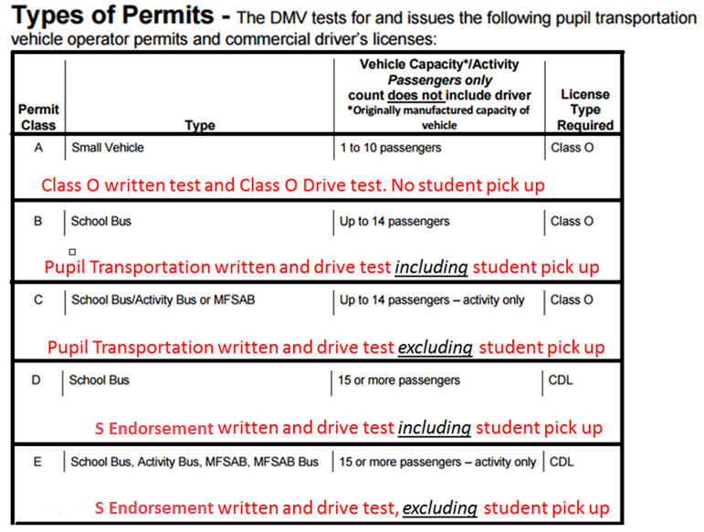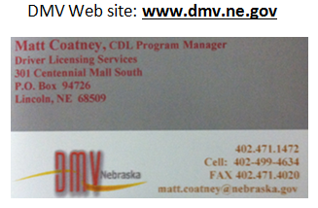
FAQ’S of the DMV
Question- Do you have to send your Medical Card in every year?
Answer- If you are referring to the DOT medical examiner’s certificate for your CDL, you only have to send that in when the old one expires. If you are referring to the long form physical for the Bus Permit, then you must bring that in to a DMV office on a yearly basis to renew your Bus Permit.

Question- When can an applicant call in and make an appointment for the skills?
Answer- You can call the day after you obtain the CLP, but keep in mind that you have to schedule it out 14 days from the day of issue.

Question- If an applicant has a CDL with the L or E restriction, what do you have to do to remove them?
Answer- To remove the L restriction (no air brakes), the Vehicle Inspection is required in an air brake equipped vehicle. To remove the E restriction (automatic transmission), the Vehicle Inspection and Road Test are required. A New CLP is required to remove either or both and you have to take the written air brake test to get the new CLP to remove the L restriction.

Question- For the Vehicle Inspection, if the bus has a master switch that systematically goes through all the light operations, can the applicant use this for the external light operations check?
Answer- Yes

Question- When going from a Class C to a Class B bus, is testing required?
Answer- Yes, you have to obtain a CLP first and then do all three segments of the skills testing to upgrade.

Question- On the Road Test (Bus Permit or CDL), do you have to engage the parking brake when stopping at a Railroad Crossing?
Answer- The requirement on the Class B/C/D/E Bus Permit states that you either have to put it in park or neutral and apply the parking brake OR press down on the service brake. There are no requirements for the brake on the CDL Road Test for the railroad crossing.

Question- On the Road Test (Bus Permit or CDL), when do you close the door at a Railroad Crossing?
Answer- The doors must be closed before the rear wheels clear the RR tracks.

Question- On the Road Test (Bus Permit or CDL), when do you turn off the hazard lights at the Railroad Crossing?
Answer- As soon as the rear wheels clear the RR tracks.

Question- If I am trying to get my CDL and Bus Permit on the same day, can I take the Bus Permit Road Test if I don’t pass all three segments of the CDL test?
Answer- No, you have to pass all tests for the CDL to proceed with the Bus Permit test, but they can be given on the same day if you do pass the CDL portion. Keep in mind – the CDL S endorsement written test is the same test given for the Bus Permit Class D/E. Thus, if you pass the S endorsement written test for the CDL, that will cover the Bus Permit Class D/E written test also.

Question- If I am doing an Activity only Bus Permit, but bring in a regular school bus with stop arm controls for the CDL test, do I have to do the Student Discharge part of the CDL Road Test?
Answer- Yes. If a driver seeking the S endorsement uses a yellow school bus with stop arms and student lights, they must perform the Student Discharge part of the CDL Road Test, regardless of the type of Bus Permit they will be seeking.

Process for Bus Permits- Nebraska Safety Center
Level I Course (for individuals wanting to get their bus permit):
- Recommended that CLP or CDL is acquired first, but not required.
- Must turn in Pre-Service Evaluation either at the Level I Course, or fax it to the NSC within 6 months of taking the Level I Course.
  - NSC must have Pre-Service Evaluation before driver can go to DMV to test for bus permit
  - If the vehicle that the person will be driving requires a CDL, a CLP or CDL must be held before completing the Pre-Service Evaluation.
    - Pre-Service Evaluation form can be found on website: www.unk.edu/bus under “+ Level I”
- Level I Course is valid for 5 years, then must take Level II Course
Level II Course (refresher course for drivers with bus permits):
- Taken within 5 years of Level I Course, and then every 5 years thereafter
  - Schools are required to keep track of drivers’ Level I and II Course dates
- NSC will send out reminder postcards 6 months and 3 months prior to Level I/II expiration
Level I/II Waivers
- Online test to receive a 60 day extension to get into a Level I/II course
  - Does NOT replace Level I/II Course
- Used if there isn’t a class available before your Level I/II Course expires
  - Please note: There are NO exemptions if a Level II Course isn’t taken within 5 years of the Level I/II Course. A driver will have to take Level I Course again if they want to continue driving.
FAQs of the Nebraska Safety Center:
Q: Why isn’t my Level I information showing up at the DMV?
A: The Pre-Service Evaluation probably has not been faxed over to the Nebraska Safety Center. If there is questions on if we have received it or not, please call.
Q: When is the next Level I/II course in ________?
A: All available courses are available on our website: www.unk.edu/bus. They can be found under the “+ Level I” or “+ Level II”. If you click on the months available, it will pull up a PDF with upcoming dates.
Q: How do I register for a course?
A: The registration form can be found on our website: www.unk.edu/bus. It is under the “+ Level I” or “+ Level II”. The registration form is located right underneath where the months for training dates are listed.
Q: Can I do a Distance Learning class from my school?
A: Yes, if your school has distance learning capabilities. All Distance Learning classes will need to be proctored by someone not taking the class and not related to anyone in the course. Please call (308) 865-1287 for more information on how to set that up. In order to set that up, we will need the name, phone number, and email of the person that will be proctoring the course.

Contact information for Rachel Leigh:
Phone: (308) 865-1287 Fax: (308) 865-8257 Email: bus@unk.edu

Questions Frequently asked in the Level I/II Training
*Page numbers refer to where the answer can be found in the Pupil Transportation Guide
A copy of the Pupil Transportation Guide can be found on the Nebraska Safety Center’s Website: www.unk.edu/bus
- Do you have to do a pre-trip inspection on a small vehicle?
The State of Nebraska requires that all vehicles that transport students are required to perform a pre-trip inspection as well as a post-trip inspection (pg. 9)

- Who is required to have a MVR done annually?
Bus drivers and small vehicle route drivers are required to have their MVR run at the beginning of each school year. This is to be kept on file. (Pg.39 Appendix 3 and Pg. 1)

- All pupil transportation vehicles are required to have a Safe Pupil Transportation Plan. What is this? What is required to be on it?
(Pg.18)

- What is the State of Nebraska's law with regards to headlights?
Nebraska law states headlights on pupil transportation vehicles must be on at all times. (Pg.7)

- Who is required to participate in bus evacuation drills, and how many annually?
Any student that has the potential to ride a school bus will be included in an evacuation drill a minimum of two times a school year. (Pg.7)

- Who is required to have a school bus permit? And what does the State of Nebraska consider to be a route?
A school bus permit is required for the driver of all vehicles used to transport one or more school children. A route is considered a daily, weekly, and or monthly scheduled trip. (Pg.1)

- Can a bus back up on school grounds? Onto the roadway?
A school bus driver shall not back up on school grounds unless the vehicle is observed and directed by a second responsible person. The driver of a school bus shall not back up on any roadway unless such movement can be made with safety and without interfering with other traffic. (Pg.7)

- What does the State of Nebraska consider authorized passengers?
School personnel and school children regularly assigned to a school vehicle for a route or approved activity can ride in the school vehicles. Supervisory and monitoring personnel are recognized as authorized passengers. (Pg. 7)

- Do seat belts have to be worn on buses? On cars? What about car seats?
When Seatbelts are provided in a school vehicle all passengers must use them. Children under the age of six must be seated in an appropriate car seat when the school vehicle is equipped with seatbelts.

Before School Reminders for Administrators from the Department of Education:
- Review Driver files for expiration dates
- Confirm newly hired drivers have met all licensing requirements
- Verify DMV driving records for all drivers
- Verify that all pupil transportation vehicles have been inspected
- Confirm that district is participating in a testing program for alcohol/controlled substances
- Establish date for Emergency Evacuations during school year
- If contracting for transportation, confirm provider follows Rule NDE 91 and 92
- Schedule a driver meeting to discuss/review state regulations and local policies

Available on NDE Pupil Transportation Web Page: https://www.education.ne.gov/FOS/OrgServices/PupilTrans/Index.html
- NDE Pupil Transportation Reminders – 2016
- Pupil Transportation Director Beginning of School Year Checklist
- NHTSA (National Highway Traffic Safety Administration) School Bus Driver In-Service Safety Series

